Jeanne-Marie Palermino
BIOC 404
17/03/06

On Friday, Dr. Gehring had 3 handouts with practice problems. One of the practice problems is not on the web… a sneaky trick to reward those who go to class.

Strategies for Assigning Residues from Homonuclear and Heteronuclear

For homonuclear:

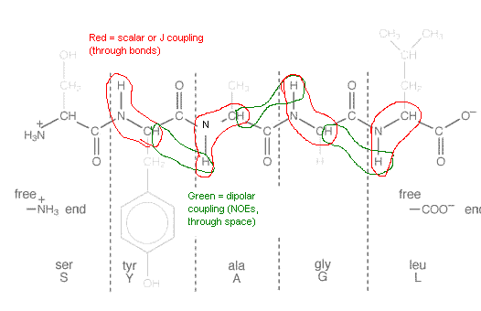

With heteronuclear:

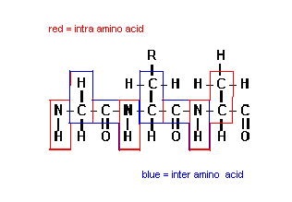
Heteronuclear experiments allow one to correlate the frequencies of HN, Hα, 15N, 13Cα and13Cβ within an amino acid and between amino acids, as depicted in the above figure.

There are two big differences between homonuclear and heteronuclear experiments, one being that we can use scalar couplings in heteronuclear experiments to go between amino acids whereas in homonuclear experiments, we are restricted to working within an amino acid. In homonuclear experiments, the carbonyl carbon lacks a proton. Thus, there is a break in series of scalar couplings which is not the case in heteronuclear experiments which have 13C everywhere. This allows a series of 1 bond couplings to create J-coupling partners all along the protein.

The other big difference is that in homonuclear experiments, we only have 2 frequencies (HN and Hα) and so there is a good deal of overlap between the HN’s of more than one residue or between the Hα’s of several residues. Due to the fact that heteronuclear experiments have 5 frequencies (HN, Hα, 15N, 13Cα and13Cβ) overlapping can be resolved. For instance, if there is overlap between two HN signals, then, by looking at the HN/15N 2D spectra, can separate the signals. Similarly, if the Hα’s overlap, then can use the 13C/Hα 2D spectra to separate them. Thus, heteronuclear experiments allow us to work with much larger proteins.

Structure Determination Overview

The sample is by far the most important factor in determining NMR structures. Thus, it is imperative to prepare a good sample. A good sample is one where the protein is concentrated in the millimolar range. That may not seem like a lot but, for a 20kDa protein, one would need approximately 10 mg of protein in a 0.5 mL sample. Thus, your sample would be about 2% protein and the remaining 98% would be water. In addition, the protein has to be stable so inactivation of proteases and addition of reducing agents to prevent disulfide bond formation are important steps in sample preparation.

Once you have your sample ready, you can now run the NMR experiments, either 2D, 3D or even 4D. Once your spectra have been obtained, you can begin doing sequence-specific resonance assignments. Completed assignments enable secondary structure determination to determine which residues are on alpha helices, beta sheets, etc. (which will be explained later). Conformation constraint information is then analyzed which gives additional information about secondary structures as well as residue location (on the surface or within the protein). At this point, the 3D structure model can be obtained. This step is sometimes circular because information based on the 1st predicted structure may need to be refined now that there is a better understanding of the structure. What is not shown in this diagram is that sometimes one must go all the way back to the beginning. Often, with sequence specific resonance assignments, the determined structure may add unfolded part of the protein to the domain or part of a helix may be missing. So, when we reclone the protein with the proper secondary structure on it, then it will be more stable. This will improve the spectra, the assignments and thus the overall 3D structure. Consequently, this is a bit of an iterative process.

It is easy to go back and forth with NMR and figure out the mistakes compared to X-ray crystallography. However, there is a weight limit for NMR of about 30-40 kDa which is not the case for X-Ray crystallography. Thus, it is now common to combine NMR and X-ray crystallography for optimal 3D structure determination, even for 20kDa proteins.

Although this wasn’t discussed further, Dr. Gehring stated that with large proteins, it helps to have some deuterated protons even if you lose some signals. In addition, it is easier to work with a symmetrical 20kDa protein because we have only approximately 90 amino acids to work with vs. 180 if it were unsymmetrical.

NMR Structural Information

Once we have our backbone structural information from our assignments, we can measure the backbone and side chain angles using scalar couplings.

NOEs indicate that two nuclei are at least within a 5 Å distance from each other. So, if a NOESY indicates that two protons are close together, then the structure must be sure to bring them close together.

As mentioned earlier, resonance assignments themselves give backbone conformational information. In 450, we saw a 2D spectra where unfolded signals all clumped together but were much more spread out in folded proteins. Also, referring to the “Chemical Shift Index” slide, we can see that alpha helices are positively shifted from the random coil and (although not shown), beta sheet residues are negatively shifted in reference to the random coil.

Thus, NOESYs, scalar couplings, chemical shifts, hydrogen bond constraints and residual dipolar couplings can all be used as structural constraints to determine a protein’s structure.

Correlation of Scalar Couplings with Secondary Structure

There is an empirical relationship between the size of a J coupling between two nuclei and the angle between them where J = A + Bcosθ + Ccos²θ. When θ=0,180, the J couplings tend to be large and when θ = 60, they tend to be small.

Dr. Gehring didn’t go over this in class but I’m just adding it to help people understand why this is the case (if you’re interested). Since information is carried from nuclei by electrons, the more the electrons overlap, the better they are able to transmit the information from its orbital to a neighboring one. When θ=0,180 (such as cis or trans with double bonds), there is much more overlap than when θ=90. To illustrate my point, refer to the diagram below:

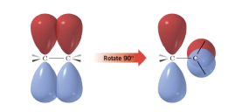

Thus, if θ=60, there is much less overlap than if the angle were equal to 0 or 180.

Back to Gehring’s lecture:

By measuring ³J(HN,Hα), we can obtain the phi angle of that amino acid since the two are directly related. Although some means have been devised to measure the psi angle, it is much more efficient to measure the phi angle. Referring to the Ramachandran plot, we can see that amino acids in alpha helices tend to have phi angles around -57 and those in beta sheets tend to have phi angles around -130. There is a small, measurable difference in the phi angle for an alpha helix and that for a beta sheet so that alpha helices tend to have smaller J-couplings between HN-Hα than beta sheets. The following figure is an example of being able to predict the positions of two alpha helices and four beta sheets since the residues in beta sheets have the larger ³J(HN,Hα) couplings of 8Hz and the residues in the alpha helices have the smaller ³J(HN,Hα) of 4 Hz.

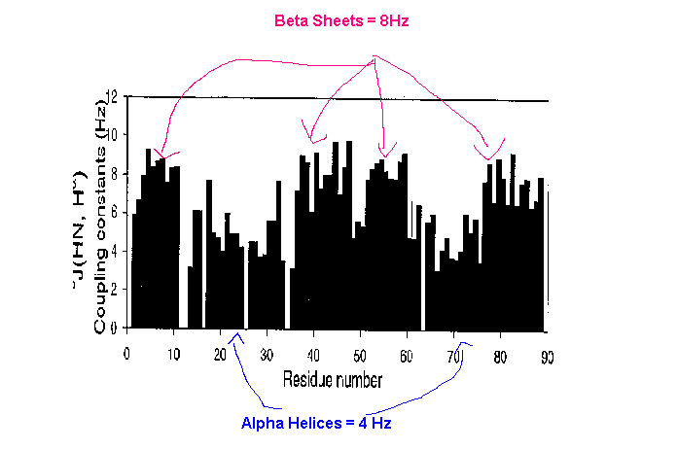

Referring to the slide “Dihedral Angles from Scalar Couplings”, we can see that for a 6 Hz 3J coupling, there are four angles possible. Unless the amino acid is something like glycine, the positive phi angles can be excluded due to the fact that only negative phi angles are allowed.

Structural Determination-NOESY

The information obtained from a NOESY spectrum is the most important of the three strategies discussed for determining a protein’s structure (Scalar Constraints, Chemical Shift Index and NOESY). Once the residues have been assigned from heteronuclear experiments, the NOESY spectrum is used to connect the HN to Hα that are close in the primary sequence and those that are far away in the primary sequence but are brought close by the tertiary structure. Thus, NOES are classified based on how far they are in the primary sequence. If there are within the same residue, they are intra-NOES. If the NOE connects two amino acids that are next to each other, then it is a sequential NOE. Medium range NOEs connect amino acids that are 1, 2 and 3 residues apart. Long range NOEs connect amino acids that are more than 4 residues apart, although some consider those that are 4 residues apart are medium range. Due to the medium and long range NOEs, there are more peaks in a NOESY spectrum than in a TOCSY so if we have 100 peaks in a TOCSY, we will have 200 from a NOESY.

The great thing about long range NOEs is that they bring different parts of the protein close together. Once we have measured all these NOEs, we can make a plot of residue number vs. number of NOEs and then classify the NOEs as being within the same residue, sequential, medium or long range. Dr. Gehring provided us with an example using GlgS, a bacterial protein:

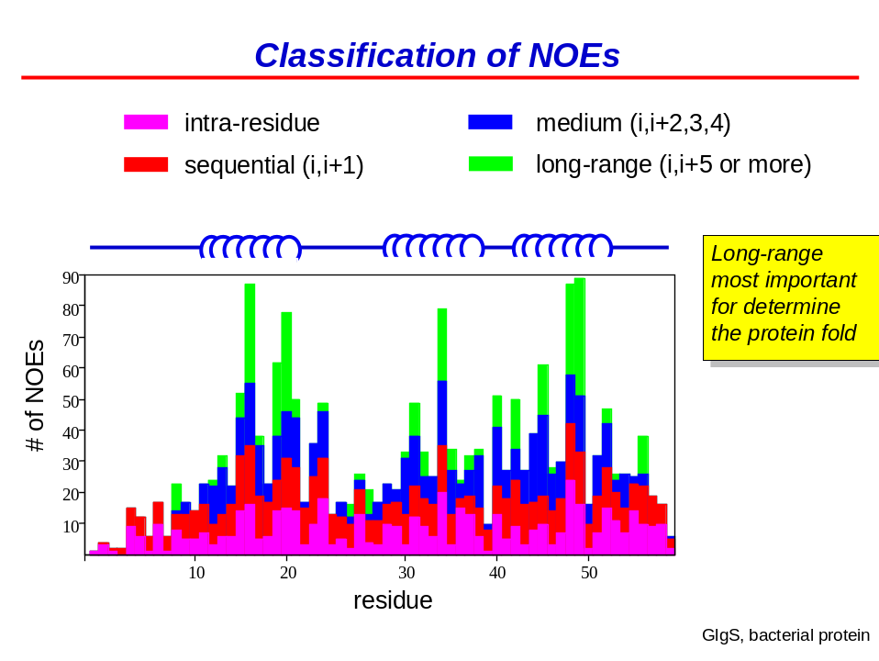

Medium range NOEs (blue) are especially useful in locating alpha helices for the amide H of residue i in an alpha helices forms an H-bond with the carbonyl oxygen of residue i+4, bringing the HN and Hα of residues i and i+4 close together. Consequently, alpha helices have a great deal of medium range NOEs whereas beta sheets do not because a residues that are even 3 amino acids are apart are further than 5 Å apart. The long range NOEs (in green) will indicate which alpha helices and beta sheets are close together which are important for holding the protein together.

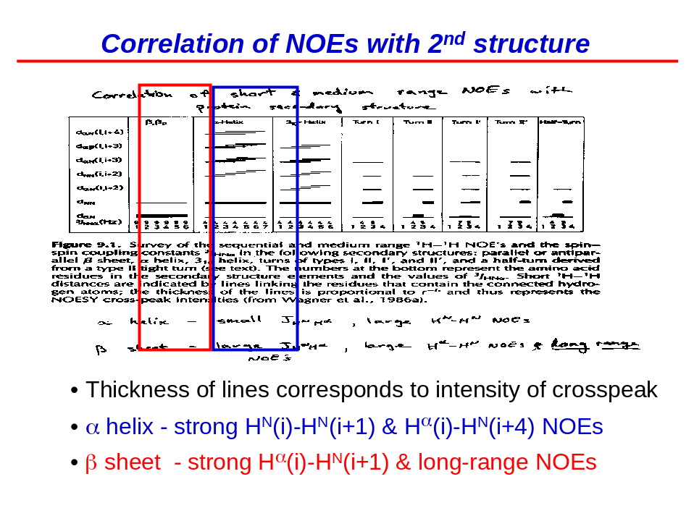
The above figure correlates the different types of NOEs (e.g. d_{αN} (i,i+4) equals HN to Hα of residues i to i+4) to secondary structures, such as beta sheets and alpha helices. The thickness of the line relates to the strength of the crosspeak. To reiterate, alpha helices have a great deal of medium range NOEs whereas beta sheets do not. However, there are significantly more sequential NOEs between the HN and Hα [d_{αN} ³J_{HNα}(Hz)] in beta sheets than in alpha helices. Yet, in alpha helices, the HN-HN sequential NOES are stronger than beta sheets. Although not seen in the above graph, long range NOES also tend to be seen in beta sheets

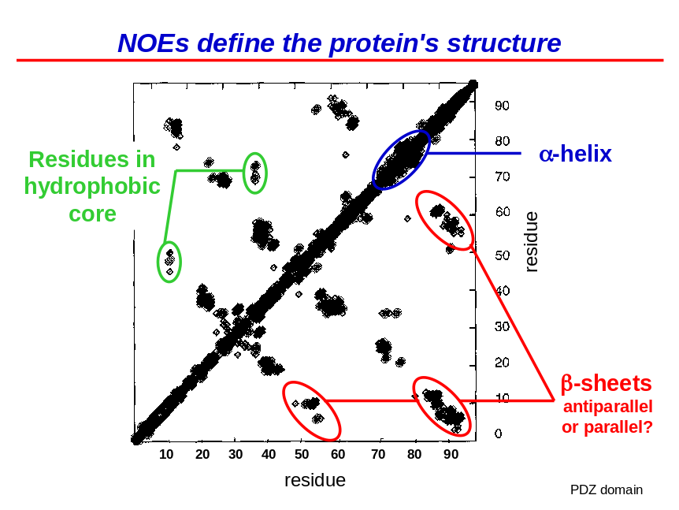

The most efficient method to manipulate NOE spectra is by plotting the crosspeaks shared between residues, an example of which is provided above. Peaks along the diagonal are intra residue NOEs, those off the diagonal by 1 are sequential; those off by 2, 3 and 4 are medium range NOEs. Peaks which are off the diagonal by more than 4 are long range NOEs. A thickened band along the diagonal represents the alpha helices due to the large number of medium range NOEs.

The red circled peaks marked beta sheets represent a series of NOEs between 2 beta sheets. This beta sheet is antiparallel because parallel beta sheets give rise to two lines parallel to the diagonal (above and below it). Hydrophobic residues also make strong NOEs.

Molecular Modeling

Statistical modeling is used to give energy terms to determine the lowest energy conformation of a protein. Multiple structures will be obtained in this manner to find which fit best with NOE and other experimental constraints. Newton’s equation of motion will be used to move molecules a very short distance. At each new distance/step, the motion and forces acting on the molecules (based on repulsion of electrons) will be measured to make a movie. If the atoms are too close together, then the van der vaals repulsions will indicate they need to be moved further apart and if there are NOEs between two residues, we know that they need to be close together. Thus, we first determine the empirical constraints from the potential energy function [PEF(R)] and then add the artificial constraints, such as NOEs, J-couplings, and Residual Dipolar Couplings (last not discussed in class). The combination of the empirical and artificial forces will show us what our protein should look like, resulting in an energy surface in conformational space. Use of molecular dynamics will enable us to use this energy surface to determine the structure with the lowest energy. Several structures will be calculated and they will be overlaid. Those with the strongest overlap are the best determined structures. However, there is little overlap at the edges of a protein and at loops because these regions are more mobile and thus less structural information is available.

Dynamics

Now that we have our structure, we can study the dynamics of protein motion. Referring to the slide labeled “Characterizing Protein Dynamics”, we can see that there are orders 15 orders of magnitude in the protein motion timescale ranging from very fast movements, like bond vibrations, to much slower movements such as protein folding and enzyme reactions. These can be measured with different NMR experiments.

How fast it takes for magnetization to grow on the z-axis when a sample is placed into the super-conducting magnet reflects the fast motions occurring in the ns to ps time scale. T1 (the reciprocal of R1, the spin lattice relaxation rate) is the time it takes for the signal to grow on the z-axis and T2 (the reciprocal of R2, the spin spin relaxation rate) is how fast the signals disappear from the x/y plane.

NMR-timescale

If you deuterate cyclohexane at all but one position and run an NMR experiment at room temperature, you will see one peak corresponding to the one H of cyclohexane. However, if you reduce the temperature to -89ºC, there will be 2 peaks, one of which will be axial and the other equatorial. This is because an axial proton is shielded differently than an equatorial proton due to anisotropy effects (not discussed in class). However, because there is not steric hindrance, cyclohexane flips between the different chair conformations so quickly at temperatures above -89ºC that the peaks begin to average so that at temperatures above -49ºC, one sharp peak is observed. The difference in frequency between two peaks is called the NMR timescale. When the exchange rate is slow compared to the difference in the peak positions, then we see a distinction between the two peaks but if the exchange is fast compared to the difference between the two, then we get an average. This can be used to calculate the rate of conversion via an Arhenius plot.

Dynamics from NMR Parameters

The rate of exchange of a ligand from its protein can be studied via chemical shift analysis.
A titration analysis is performed where the spectrum is obtained for the free protein and then subsequent spectra are obtained after the addition of ligand in small increments. In both figures below, peak A represents the chemical shift for the free, unbound ligand. In slow exchange, the ligand has a higher affinity for its binding site on the protein and thus stays bound longer than ligands undergoing fast exchange. Consequently, the exchange is slower than the NMR timescale, which is the difference between the chemical shifts of the protein in the unbound (A) and bound (B) states. Thus, as more ligand is added, B increases in size whereas A decreases but 2 distinct peaks remain visible until the protein is fully saturated where only chemical shift B will be seen on the spectrum.

For fast exchange, A still represents the free state and B still represents the bound state. However, as ligand is added, only 1 peak is seen that is between the chemical shifts A and B. As more ligand is added, this peak moves from A towards B. The rate of exchange of the protein from bound to unbound is much faster than the difference between the chemical shifts of A and B; the rate of exchange is faster than the NMR timescale. Consequently, an averaging effect occurs and only 1 peak is observed that is the same intensity throughout the titrations.
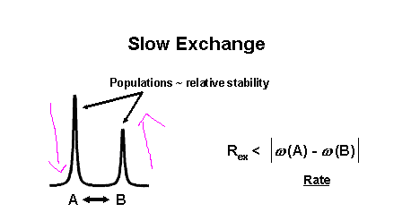

Fast Exchange

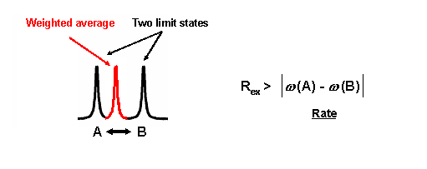

THE END! Sorry it was sooooo long!

